Paper-prototype Test Results

After completing a round of tests with the paper prototypes, each participant was given a survey to complete. The tests focussed on the game modes that have been created for the Codeverter platform as these are what make the system unique. From the teachers’ point of view, focus was put on the options and control they had for building an experience useful to their classrooms. For the students the focus was placed more into seeing if they would have fun while learning.

# Teachers

## Spaceship Game

### Results

All teachers surveyed agreed that there was a good amount of control over the content of each game, though they did have suggestions for improvements:

*“I couldn't see an option for creating teams. It would be good to be make teams of people who don't generally work together to encourage social interactions and bonding.”*

*“A little more information about what each topic includes would be good. I am not that familiar with coding so I would like to know the content of each topic before making the students learn it. That way I can help them if they have any questions.”*

(Quotes from teachers regarding the *Settings* page of the Spaceship game during paper prototyping phase).

All participants also rated the app a 4/5 for usefulness (5 being very useful and 1 being not useful).

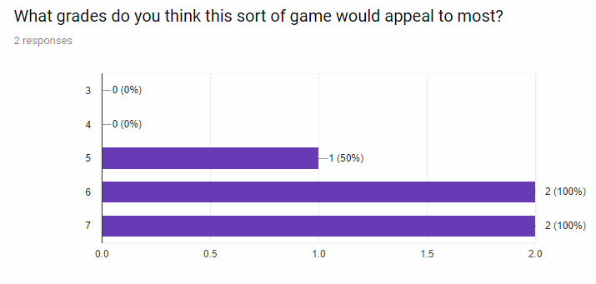

### Discussion

From the results collected during the paper prototyping it can be seen that teachers like the idea of having a tool that will engage students in a social and educational manner. A big concern for them is being able to have control over the lessons that they create using the tool. Being able to have the lesson set up in a way that suits their teaching style and is tailored to each classrooms’ needs is a must. As such Codeverter must allow for flexibility in the content of each game, making it more useful in a wider range of scenarios.

Overall they seem to genuinely like the Codverter idea and they believe that it will appeal to the desired target audience.

# Students

## Spaceship Game

All the students that participated in the testing of the spaceship game agreed that they would enjoying playing the game in a classroom setting. They also rated it as a 4/5 in terms of how much fun they thought it would be as a finished game.

As they students were in the target audience and they all enjoyed it, this is confirmation that our designs are appealing to the right age bracket.